# Chapter 6: Analysis & Design

Analysis modeling uses a combination of text and diagrammatic forms to depict requirements for data, function, and behavior in a way that is relatively easy to understand, and more important, straightforward to review for correctness, completeness and consistency. This section presents resources for conventional and object-oriented analysis (OOA) methods as well as resources for UML.

6.1 Activity Diagram

Activity diagrams describe the workflow behavior of a system. The diagrams describe the state of activities by showing the sequence of activities performed. Activity diagrams for Admin.

Enter Email & pass

Verify

Show System

Add student

Check Details

Confirm/Cancel

Update/Delete

Marks Entry

Conver Grade

Show Result

Make PDF

Add syllabus

View

Update/Delete

Book Add

Take order

Check Details

Contact

Research Post

Confirm

Publish

Update/Delete

**Activity Diagram for EMS Student:**

Enter Email & pass

Verify

Show System

Click Profile

See Profile

Click On Result

First Term

Mid Term

Assignment

Article

Final

Click On Certificate

Gratuation?

Click On Result

Waiting MSG

Figure: 6.1.2Activity Diagram for Student

## 6.2 Swim Lane Diagram

A swim lane diagram is a type of flowchart. Like a flowchart, it diagrams a process from start to finish, but it also divides these steps into categories to help distinguish which departments or employees are responsible for each set of action.(Online Admission Module)

Student

Admin

System

Database

Click On course

Show Admission form

Fill up the Admission form

Submit

Verify

Suggest to fill up

suggest to fill up

Submit

Save to DB

Waiting MSG

Get MSG

Confirm

Enlist to confirm

Update

Email with pass

Get email

**Swim Lame Diagram for Result processing:**

Student

Admin

System

Database

Entry Marks

Convert Grade

 Click on Result

 Show Result

Show MSG

 Marks,Grade,st_info to DB

 Search

Save

 View Done

Send Request

 Organize

Show Result

Result

?

 MSG No Result yet

Figure: 6.2.2 Swim Lame Diagram for Result Processing

**6.3 Sequence diagrams:**

Sequence diagrams describe interactions among classes in terms of an exchange of messages over time. They're also called event diagrams. A sequence diagram is a good way to visualize and validate various runtime scenarios. These can help to predict how a system will behave and to discover responsibilities a class may need to have in the process of modeling a new system (Sequence Diagram of Result Processing)

Show Result

Specific Query

Specification

Done MSG

Save to DB

Save

Show Grade

Marks Entry

System

Database

Admin

Figure: 6.3.1 Sequence Diagram of Result Processing

**Sequence Diagram of Online Admission:**

Show Result

Search Successful

Search Query

Click on Result

Success

Update Successful

Status 1

Enlist

Insert Successful

Submit Admission Form

Fill up Admission Form

System

Database

Student

Admin

Waiting MSG

Fig 6.3.2 Sequence Diagram of Online Admission

**6.4 ERD:** Here is the ER Diagram of the system-

Admin

Student

Syllabus

Assignment_marks

First_term_Result

Instruction

Mid_term_Result

Final_term_Result

Post

See

Add

Serve

Entry

Entry

Entry

Entry

See

See

See

See

See

1

1

1

1

1

1

1

1

1

M

M

M

M

M

M

M

6.4 Data Flow Diagram (DFD)

A data flow diagram (DFD) is a graphical representation of the "flow" of data through an information system, modeling its process aspects. A DFD is often used as a preliminary step to create an overview of the system, which can later be elaborated DFDs can also, be used for the visualization of data processing.

A DFD shows what kind of information will be input to and output from the system, where the data will come from and go to, and where the data will be stored. It does not show information about the timing of process or information about whether processes will operate in sequence or in parallel.

**Context Level Diagram:**

Automated Admission & Result Processing System

0

Admin

Admin

Admin

I/O

I/O

O

Figure 6.4. Context Level Diagram

**Level 1 DFD for the System:**

Website

111

Publication

21

Admission

31

Login

41

Profile

51

Result

61

Article

71

Notice

81

Certificate

91

Admin

G. People

Student

DB

hr_sys

See Contents

Upload Post

Confirm Admission

Enter Email,pass

Mange Result

Upload Article

Profile Update

Upload Instruction

Issue

Get PDF

Figure 6.4.1 Level 01 Diagram

**Level 2 DFD of Process 1 (Website):**

Figure 6.4.2 Level 01 Diagram

Home

1.1

Courses

1.2

Publication

1.3

Article

1.4

Gellary

1.5

Slider

1.6

Contact

1.7

Admin

G. People

DB

Upload

Upload

View

Upload

Upload

Upload

Upload

View

**Level 2 DFD of Process 2 (Publication):**

Show Advertize

2.1

Show details

2.2

Calculator

2.3

Sign up

2.4

Login

2.5

Shipping

2.6

Cart

2.7

Confirmation

2.8

Admin

G. People

DB

Manage Info

See

I

Input

MSG

Confirm

Upload Contents

Figure 6.4.3 Level 01 Diagram

**Level 2 DFD of Process 3 (Admission):**

Admission form

3.1

Admission Confirm

3.2

Login

3.3

Dashboard

3.4

Profile

3.5

Result

3.6

Notification

3.7

Admin

Student

DB

I

Post

Status Change

Get

Manage Info

Manage Info

Child Diagram Process 3

Figure 6.4.4 Level 01 Diagram

**Level 2 DFD of Process 6 (Result):**

Add Marks

6.1

Grade Converter

6.2

Result Display

6.3

Updater

6.4

Report Generator

6.5

Printer

6.6

Admin

Student

DB

Entry

Get

Add to DB

Figure 6.4.5 Level 01 Diagram

**Level 2 DFD of Process 1 (Article):**

Article manager

7.1

Article Publisher

7.2

Updater

7.3

Display

7.4

Admin

Student

DB

G.People

Post

Approve

See

Figure 6.4.6 Level 01 Diagram

**Level 2 DFD of Process 1 (Website):**

Certificate manager

9.1

Certificate Generator

9.2

PDF Maker

9.3

Printer

9.4

Admin

Student

DB

Approve

Click

Get

Figure 6.4.7 Level 01 Diagram

**6.7 CRC:**

CRC means class responsibility collaborator.

|  |  |
| --- | --- |
| Class Name : Admin  Class Type : Role  Class Characteristic : Tangible | |
| Responsibility   * Verify all accounts * Create new accounts * Update all accounts * Delete accounts |  |

|  |  |
| --- | --- |
| Class Name : Student  Class Type : Role  Class Characteristic : Tangible | |
| Responsibility   * Add new student * Update student * View all student list * Delete student |  |

|  |  |
| --- | --- |
| Class Name : Admission  Class Type : Role  Class Characteristic : Tangible | |
| Responsibility   * Fill up online Admission form * Confirm by admin * Getting email notification with login passwod |  |

|  |  |
| --- | --- |
| Class Name : Result  Class Type : Role  Class Characteristic : Tangible | |
| Responsibility   * Admin can upload Result * Student can see result * Calculate Grade * Report Generate |  |

|  |  |
| --- | --- |
| Class Name : Grade  Class Type : Role  Class Characteristic : Tangible | |
| Responsibility   * Admin can upload Result * Student can see result * Calculate Grade * Report Generate |  |

|  |  |
| --- | --- |
| Class Name : ExamsMarks  Class Type : Role  Class Characteristic : Tangible | |
| Responsibility   * Admin can Entry marks * Student can see result * Calculate Grade * Report Generate |  |

|  |  |
| --- | --- |
| Class Name : Assignment &article  Class Type : Role  Class Characteristic : Tangible | |
| Responsibility   * Admin can upload Result * Student can see result * Calculate Grade * Report Generate |  |

|  |  |
| --- | --- |
| Class Name : Certificate  Class Type : Role  Class Characteristic : Tangible | |
| Responsibility   * Admin can upload Result * Student can see result * Calculate Grade * Report Generate |  |

**6.8 Class Diagram:**

Admin

+name

+password

+activate Status

+add()

+delete()

+update()

Admission

+apply_id

+date

+applicant_name

+apply()

+getEmail()

+generatePassword()

Student

+name

+password

+Address

+contact

+seeResult()

+profile()

+publishArticle()

+getNotification()

Result

+exam_name

+maks

+date

+add()

+delete()

+update()

Term Exams

+term_name

+marks

+subject

+student_name

+add()

+delete()

+update()

Assignment&Article

+assign&art_name

+marks

+subject

+student_name

+add()

+delete()

+update()

Grade

+student_name

+graduation_date

+grade

+add()

+delete()

+update()

Certificate

+stu_name

+Address

+Grade

+authority_sign

+add()

+delete()

+update()

1

1..*

1

1..*

1

1

1

1..*

1..*

1

1

1

1

1

**Interface Design**

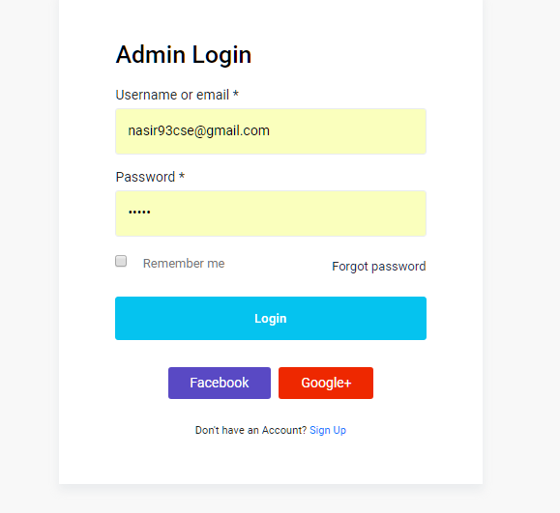

Figure: Login Panel for Admin and Student

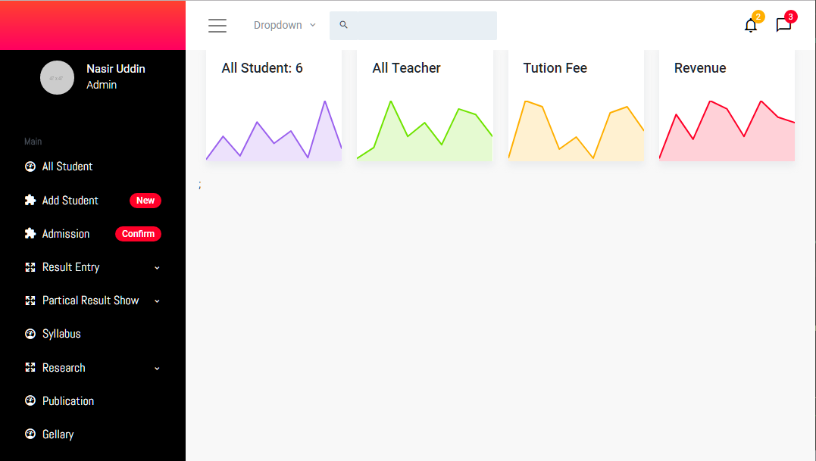

Figure: Admin Panel and options

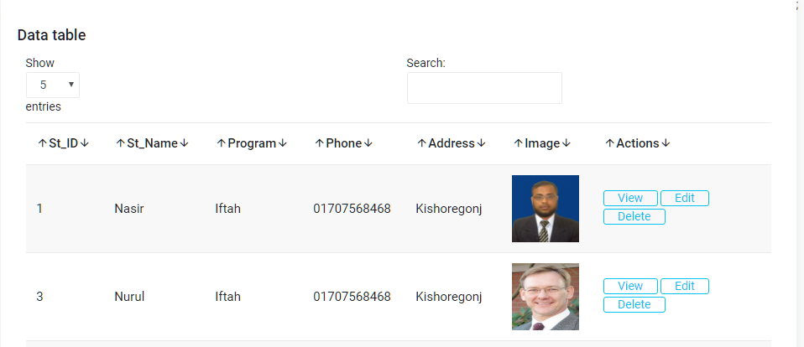

Figure: All Student list and details



Figure: Student Profile with details

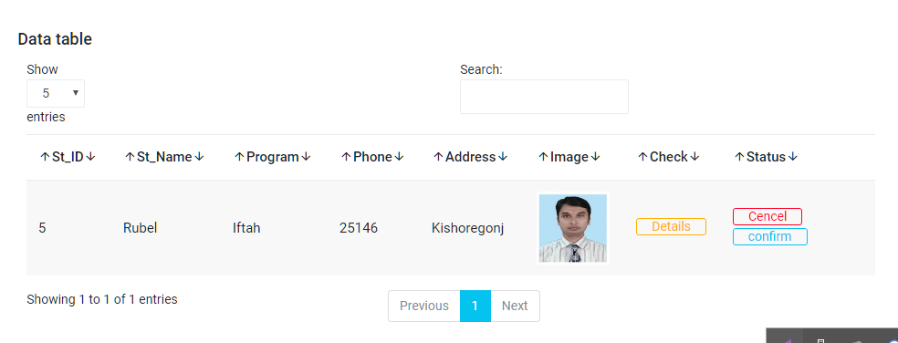

Figure: Admission confirmation list

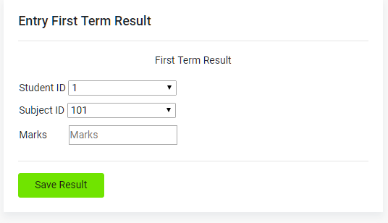

Figure: Result Entry for particular Student

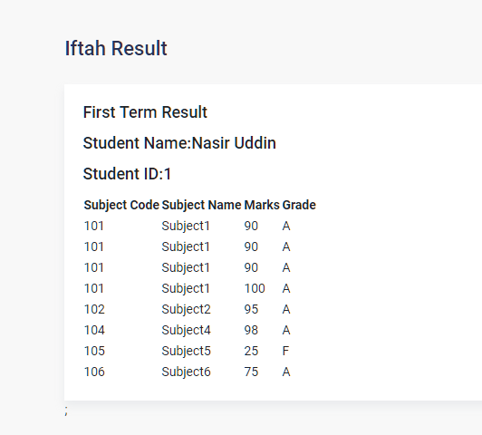

Figure: See Result for particular Student